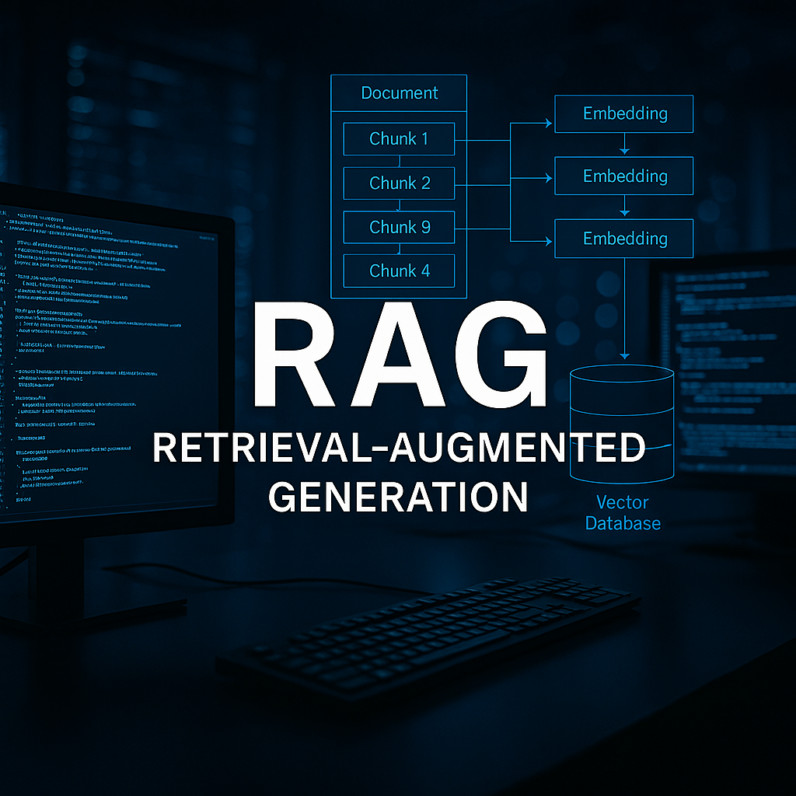

MakerAi 2.5

RAG
CimaMaker
Correo electrónico: gustavoeenriquez@gmail.com  Sitio web: https://makerai.cimamaker.com | Tel.: +573128441700  Doc. Versión 1.0 | 
Contenido
1: La Revolución RAG y su Gran Debate 4
1. El Problema Original: Las Cadenas de los LLMs 4
2. La Solución Elegante: ¿Qué es RAG? 7
3. El Debate Central: ¿Ha Muerto RAG? RAG vs. Ventanas de Contexto Gigantes 10
Módulo 2: Anatomía de un Sistema RAG Fundamental 13
Fase 1: La Indexación y el Arte de "Chunking" 13
A. Carga de Datos (Data Loading) 13
B. El Dilema del Chunking: La Decisión más Crítica 14
C. Creación de Embeddings: Convirtiendo Palabras en Coordenadas Mágicas 15
D. Almacenamiento (Vector Stores): La Biblioteca para Vectores 17
Módulo 3: ¡Manos a la Obra! Construyendo tu Primer RAG con MakerAi Delphi Suite 19
Objetivo del Tutorial 19
1. Tutorial: Creando un RAG Básico en Delphi 19
Paso 1: Configuración del Entorno 19
Paso 2: Diseño de la Interfaz de Usuario en Delphi 20
Paso 3: La Fase de Indexación (Cargar, Dividir y Almacenar) 20
Paso 4: La Fase de Inferencia (Buscar y Generar Respuesta) 21
Paso 5: Probar el Sistema y Observar sus Limitaciones 23
Ahora, busquemos las grietas (las limitaciones): 23
Módulo 4: Masterclass de Optimización: Creando un Ecosistema RAG de Producción 24
1. Capítulo 1: El Catálogo Definitivo de Estrategias de Chunking 24
Categoría 1: Estrategias Básicas (Basadas en Estructura Fija) 24
Categoría 2: Estrategias Conscientes del Contenido y la Estructura 25
Categoría 3: Estrategias Avanzadas y Semánticas 25
2. Capítulo 2: Más Allá de la Búsqueda Simple: Transformaciones y Enrutamiento 26
Técnica 1: Transformación de la Consulta (Query Transformation) 26
Técnica 2: Enrutamiento Inteligente (Routing) 27
3. Capítulo 3: Mejorando la Relevancia: Re-ranking y Autocorrección 27
Técnica 1: Re-clasificación (Re-ranking) 27
Técnica 2: Flujos Agénticos de Autocorrección (Self-Correction) 28
Módulo 5: Las Fronteras de RAG: Datos Estructurados y Multimodalidad 30
1. RAG no es Suficiente: La Transición al RAG Estructurado 30
El Problema: RAG Opera con "Vibras", no con Lógica 30
La Solución: RAG Estructurado y Grafos de Conocimiento 30
¿Cómo encaja MakerAi Delphi Suite en esto? 31
2. El Reto Multimodal: ¿Puede RAG "Ver" y Entender? 32
Módulo 6: Del Prototipo a la Realidad: Evaluación y Despliegue 34
1. Evaluación Rigurosa: ¿Cómo Sabemos si Nuestro RAG Funciona? 34
Métricas Clave (Basadas en el framework RAGAs) 34
2. Puesta en Producción (Deployment) 36
Apéndice A: Glosario de Términos Clave 38
Apéndice B: Ecosistema de Herramientas y Componentes 40
Apéndice C: Búsqueda de Similitud de Vectores con pgvector 42
C.1 ¿Qué es pgvector? 42
C.2 Instalación de pgvector 42
C.3 Uso Básico de pgvector 43
C.4 Indexación para Búsquedas Rápidas (ANN) 44
C.5 Preparación del Entorno de Compilación en Windows 10 y 11 46

1: The RAG Revolution and its Great Debate
Welcome to this manual! If you're here, chances are you've been fascinated by the incredible capabilities of Large Language Models (LLMs) like GPT-4, Llama 3, or Claude 3. We've entered an era where we can "converse" with technology, asking it to write code, summarize complex texts, or even create poetry. His abilities seem almost magical.
However, when we try to bring this magic to serious business applications—like achatbotcustomer support, a financial analysis assistant or a search tool for legal documents—we quickly came across a harsh reality. The brilliance of LLMs comes with a series of "chains" that limit their reliability and usefulness in the real world.
In this first module, we will explore those chains. Understanding the problem is the first and most crucial step in appreciating the elegance and necessity of the solution: Recovery Augmented Generation, or RAG.

1. The Original Problem: The Chains of LLMs
Imagine you hire an incredibly smart intern. He learns very quickly, has a prodigious memory of everything he studied until the day of his final exam, and writes reports in an eloquent and convincing way. Sounds great, right? But you soon discover three fundamental problems in the way they work. These problems are exactly what standard LLMs suffer from.
A "hallucination" occurs when an LLM generates an answer that is factually incorrect, made up, or simply absurd, but presents it with complete confidence and authority.
- Why does it happen?LLMs are, in essence, incredibly sophisticated word prediction engines. They do not "think" or "consult" a database of facts. Their main goal is to generate a sequence of words that is statistically coherent and plausible, based on the patterns they learned from billions of texts on the Internet. If you need to invent a fact, a quote, or a code function to maintain consistency, you will do so without hesitation.
- The Analogy:It's like our brilliant intern who, instead of admitting that he doesn't know the answer to a question, prefers to invent an answer thatsuenecorrect so as not to look bad.
- The Business Impact:This is the most dangerous problem. Achatbotsupport team that invents features of a product can generate a customer crisis. A paralegal citing a nonexistent court case can lead to catastrophic decisions. Confidence is the cornerstone of any professional application, and hallucinations destroy it.

Example of Hallucination:
Usuario:What is the function in the Python "pandas" library to calculate the Spearman-Brown correlation?
LLM (Alucinando):Sure! You can use the function "pandas.DataFrame.corr(method='spearman_brown')". It is very efficient for reliability analysis.
Realidad:This function does not exist. The LLM has invented it because it sounds plausible, combining "spearman" (an actual method) with "spearman-brown" (a real statistical concept but not implemented like this in pandas). A developer could waste hours searching for the bug.
LLMs do not learn in real time. They are trained on a massive data set that has a "cutoff date" (knowledge cutoff). They know nothing of what has happened in the world after that date.
- Why does it happen?Training for a foundational LLM is a monumentally expensive and time-consuming process, which can take weeks or months and cost millions of dollars. Therefore, it cannot be done continuously.
- The Analogy:Our intern is a world expert in everything... until the year he graduated. Ask him about any event, scientific discovery, or market trend after that date, and he won't have a clue.
- The Business Impact:Imagine achatbotfinancier who does not know the results of the last quarter of a company. Or a marketing assistant who is not aware of the new social network that is trending. Applications that depend on current information become useless.

Example of Outdated Knowledge:
Usuario:Who won the 2022 FIFA World Cup?
LLM (with cut-off date in 2021):As my knowledge stops in 2021, I have no information about the 2022 World Cup. The last winner I have record of is France, in 2018.
Nota:In this case, the model is honest. The worst case scenario is that you try to "guess" and hallucinate a winner.
When an LLM gives you an answer, how did they come to that conclusion? What sources was it based on? In most cases, there is no way to know. The generation process is opaque.
- Why does it happen?The response is not extracted from a specific source, but is generated from the synthesis of complex patterns learned from your entire training data set. There is no "source document" for most answers.
- The Analogy:It's as if the intern handed you a report with a brilliant conclusion: "We should invest in market X." When you ask him for his sources, data, or the reasoning behind it, he simply responds, "Trust me, I know."
- The Business Impact:The lack of traceability and verifiability is unacceptable in professional environments. A doctor cannot trust an AI diagnosis without seeing the evidence. An analyst cannot recommend an investment without being able to audit the data. Without sources, there is no trust, there is no debugging, and there is no accountability.

The Problem | The Analogy | The Business Impact
Alucinaciones | The intern who invents answers to avoid looking bad. | Total loss of trust, legal and financial risk.
Conocimiento Desactualizado | The expert who graduated years ago and hasn't updated. | Irrelevant or incorrect information for current decisions.
The Black Box | The genius who cannot show his work or cite his sources. | Inability to verify, audit or trust responses.

These three chains—the tendency to invent, the anchorage in the past, and the inability to cite sources—make LLMs, by themselves, toolsfascinantesbut unreliable for tasks that require precision and truthfulness.
Does this mean they are useless for serious applications? At all. It means thatnecesitan ayuda. They need a way to connect to reality, to verifiable facts, to documents oftucompany and current knowledge.
They need us to give them an open book for the exam. And that, precisely, is the idea behind RAG.

2. The Elegant Solution: What is RAG?
After identifying the chains that bind LLMs—hallucinations, outdated knowledge, and their black box nature—the question becomes obvious: how do we break them?
We could think of complex solutions, such asre-entrenarConstantly update the model with new data. But this is prohibitively expensive and slow, like forcing our intern to repeat his entire university degree every month to stay up to date.
The AI community found a much more practical, efficient and, above all, elegant solution:RAG (Retrieval-Augmented Generation), or Increased Generation by Recovery.
The Ultimate Analogy: The Open Book Exam
The core idea of RAG is incredibly intuitive. Instead of relying solely on the internal and often imperfect memory of the LLM (the rote exam), we give you access to a reliable, external source of information at the exact moment you need it (the open-book exam).
Think about it like this:
- Standard LLM (Memory Exam):You ask our brilliant intern a question about a very specific topic, such as the details of your company's latest financial report. He has never seen that report, so based on his general knowledge of finances, he tries to "guess" an answer that sounds coherent. The result is at best vague and at worst a dangerous hallucination.
- LLM with RAG (Open Book Examination):Before you ask him the question, you hand him a copy of the financial report and say: "based ononlyin this document, answer my question". Now, the intern doesn't have to guess. Simply read the relevant passage from the report and summarize the correct answer. Also, if you ask him where he got the information from, he can point out the page number and the exact paragraph.
That's RAG.It is the process of giving an LLM the exact context it needs to answer a question, right before it answers it.
Formal Definition and its Two Key Phases
RAG (Retrieval-Augmented Generation)is an architecture that combines an information retrieval system (the "Retriever") with a large language model (the "Generator" or LLM). system firstrecuperafragments of relevant information from a knowledge base and then uses them toaumentarthe prompt that is sent to the LLM so thatgenerethe final answer.
The process is divided into two different and sequential phases:
- Recovery Phase (Retrieval): The Intelligent Librarian
  - Objetivo:Find the information most relevant to the user's question within a vast collection of documents (product manuals, legal articles, transcripts, etc.).
  - How does it work?When the user asks a question, the system does not send it directly to the LLM. First, it uses search algorithms (usually semantic similarity search) to comb a pre-prepared knowledge database and extract the "chunks" or "chunks" text that are most likely to contain the answer.
  - The Result:This phase produces a set of highly relevant text fragments. For example, if you ask "What is the return policy?", the retriever might find three paragraphs of internal documentation that describe that policy.
- Generation Phase: The Eloquent Synthesizer
  - Objetivo:Use the information retrieved to generate a natural, accurate and useful response for the user.
  - How does it work?The system takes the fragments retrieved in the previous phase and inserts them, along with the user's original question, into a prompt template. This "augmented prompt" is what is ultimately sent to the LLM.
  - Augmented Prompt Example:
Contexto Relevante:
- Excerpt 1: "Our policy allows returns within 30 days of purchase, as long as the product is in its original packaging."
- Fragment 2: "To initiate a return, the customer must contact support@empresa.com with their order number."
- Fragment 3: "Products on final offer are not eligible for returns."

Based solely on the context above, answer the following question:
User Question: What is the return policy and how can I return an item?
The Result:The LLM, now with all the necessary information in front of it, can generate an accurate and complete response, such as: "You may return an item within 30 days of purchase if it is in its original packaging. To do so, contactsoporte@empresa.comwith your order number. Please note that products on final offer cannot be returned."

Architecture Diagram of a Basic RAG System
Visualizing the flow helps consolidate the concept. Here is a simplified diagram of how the components interact:
- User Question:The user initiates the interaction.
- Recuperador (Retriever):The question becomes a numerical representation (embedding) and is used to search theVector Knowledge Base (Vector Store).
- Contexto Relevante:The retriever returns the most similar text fragments (Top-K).
- Prompt Aumentado:The original question and the recovered fragments are combined into a prompt.
- Generador (LLM):The LLM receives the augmented prompt and generates the final response.
- Respuesta Final:The response is presented to the user, often with the option to view the fonts used.

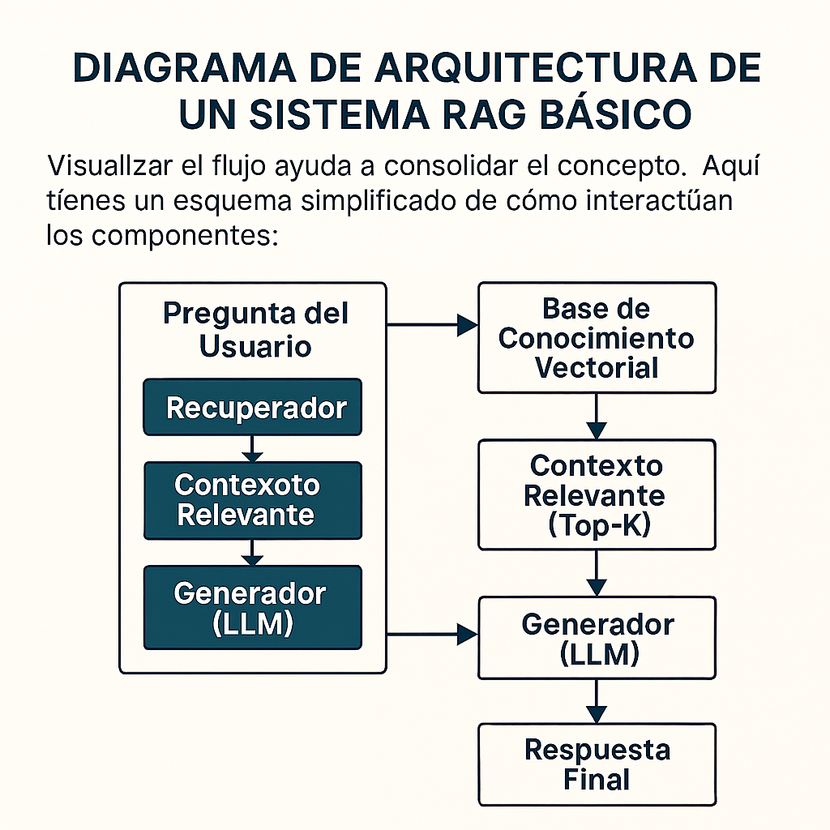

By adopting this architecture, RAG breaks the three chains of LLMs directly and effectively:
- Fight Hallucinations:When instructing the LLM to base their responseonlyIn the context provided, your tendency to invent information is drastically reduced.
- Fix Outdated Knowledge:The knowledge base can be updated as often as necessary (daily, hourly) without having tore-entrenarthe LLM. If a new financial report is published, it is simply added to the knowledge base and the system can use it immediately.
- Remove the Black Box:The system is transparent. We know exactly what bits of information were used to generate the answer, allowing for verification and citation of sources.
RAG is not a magic bullet, and as we will see in the next modules, building a robust, high-quality RAG system has its own challenges. But his approach is one of the most powerful and transformative ideas in the field of applied AI today.

3. The Central Debate: Is RAG Dead? RAG vs. Giant Context Windows
Just when the AI community seemed to have established RAG as the definitive solution for connecting LLMs with external knowledge, a new wave of innovation arrived to challenge its reign:models with gigantic context windows.
Models like Google's Gemini 1.5 Pro and Anthropic's Claude 3 announced the ability to process contexts of a million tokens or more. To put it in perspective, one million tokens is equivalent toabout 1,500 pagestextbook, or the complete book of "The Lord of the Rings".
This monumental capability gave rise to a provocative question that resonates throughout AI blogs and conferences:If I can fit an entire book directly into the LLM prompt, why do I need the complexity of RAG? Has RAG died?
In this section, we will explore both sides of this fascinating debate. Understanding these arguments is key to deciding which architecture to use in your own projects.
The "RAG is Dead" Argument: The Brute Force of Simplicity
Those who proclaim the end of the RAG era rely on a powerful argument: thesimplicidad radical. The idea is that the massive context window eliminates the need for the most complex and error-prone part of the RAG architecture: theRecovery (Retrieval).
The reasoning is the following:
- Elimination of Indexing Complexity:
  - Goodbye toChunking:You no longer need to worry about how to divide documents. "War and Peace"? 10 quarterly reports? You simply concatenate them and put them all in the prompt. There is no risk of cutting an idea in half or choosing the size ofchunk incorrecto.
  - Goodbye to Embeddings and Vector Databases:You do not need to generate numerical vectors for your texts or manage a vector database infrastructure (such asPinecone, ChromaDBor FAISS). This reducessignificantly the technical complexity, infrastructure costs and points of failure.
- Perfect Context (in Theory):
  - The promise is that by giving the LLM the full document, they have access to 100% of the context. There is no risk that the retriever (the "librarian") will fail to find the correct fragment, because the LLM has the "entire library" at its disposal for the question.
The proposed new architecture, often called "In-ContextRAG" or just "long context search", it would look like this simple:
The Analogy:Instead of building a complex cataloging system and a robotic librarian to find a needle in a haystack (RAG), the new idea is:"Why don't we just put the whole haystack in a giant oven that will give us the needle back?"
This vision is seductive. Dramatically simplifies the developer's work. But is it really as perfect as it seems?
RAG Defense: Why It's Still Indispensable and Evolving
Despite the appeal of giant context windows, the reality is that RAG is not only not dead, but remains the most practical, scalable, and often most accurate architecture for most real-world applications.
Here are the key counterarguments:
- Cost and Scalability: The Elephant in the Room
  - Inference Cost:Send a million tokens to an LLM ineachconsultation is extremely expensive. LLM APIs charge per token processed (both input and output). An app with thousands of users asking questions would become financially unviable in a very short time.
  - Knowledge Scalability:Context windows, although huge, have a limit. What if your knowledge base is not a book, butmillonesof documents? The complete documentation of a multinational? All medical records from a hospital? It is impossible to put "everything" into context. RAG, on the other hand, is designed to scale to knowledge bases of virtually unlimited size.
  - Latencia:Processing a million tokens takes time. Users expect quick responses from achatbot. A RAG system, by retrieving only a few kilobytes of relevant text, is significantly faster in generating the response.
- Precision: The "Needle in a Haystack" Problem (Needle in a Haystack)
  - Studies have shown that even the best LLMs suffer from a problem called"lost in the middle"(lost in the middle). When they arepresents a very long context, they tend to pay more attention to the information found at the beginning and end of the text, often ignoring or "missing" crucial details that are in the middle.
  - In the haystack analogy, putting everything in the oven does not guarantee that the oven will find the needle. Sometimes he just burns it along with the rest.
  - A well-designed RAG system, with an accurate retriever, is like a metal detector that takes you right to the needle. It is an approach ofsurgical precision vs. brute force.
- RAG is more than a Search: It is an Optimizable Ecosystem
  - The "RAG is dead" argument oversimplifies what a modern RAG system is. It's not just about findingchunksby similarity. As we will see in the advanced modules of this manual, a production RAG system is a sophisticated ecosystem that can include:
    - Enrutamiento Inteligente:Direct the question to different databases according to their content.
    - Query Transformation:Rewrite the user's question to get better results.
    - Re-ranking:Use a second model to ensure the most relevant context is first.
    - Autocorrect:Allow the system to notice if it retrieved junk information and try again.
Conclusion of the Debate: A Hybrid Future
So who wins the debate? The most sensible answer is thatthe question is wrongly posed. It's not about "RAG vs. Long Context", but about how they can work together.
- RAG is still the king for the RECOVERY phasein large knowledge bases, where efficiency, cost and scalability are paramount.
- Long context windows are an amazing tool for the SYNTHESIS phase. Once RAG has retrieved the 10 or 20 most relevant fragments, we can afford to give them all to an LLM with a wide context window so that it has a more holistic view and generates a higher quality response.
The architecture of the future is not one or the other, but an intelligent combination of both. RAG acts as the precision filter, and the long context LLM acts as the final reasoning engine.
Far from being dead, RAG is evolving. It is becoming smarter, more modular, and more indispensable than ever for building reliable and scalable AI applications.

Module 2: Anatomy of a Fundamental RAG System
In the previous module, we established what RAG is and why it is such a powerful and relevant architecture. Now, it's time to open the hood and examine the parts that make it all work.
A RAG system, in its essence, operates in two main moments:
- The Indexing Phase (Offline):This is the prep work. It happensantesfor any user to ask a question. It is the process of taking your raw documents and transforming them into a structured andbuscable.
- The Inference Phase (Online):This is the process in real time. It happenswhenA user asks a question, using the previously indexed knowledge base to generate an answer.
In this module, we will dissect both phases. Let's start at the beginning: how we prepare knowledge.

Phase 1: Indexing and the Art of "Chunking"
The indexing phase is the foundation work of your RAG system. The quality and logic you apply here will have a direct and massive impact on the final performance of your application. If this step is done wrong, even the best LLM in the world will not be able to give good answers.
The goal of indexing is simple: convert a collection of unstructured documents (PDFs, web pages, text files) in a format that a machine can search efficiently and semantically.
This process consists of four fundamental steps:Loading, Division, Creation of Embeddings and Storage.

A. Data LoadingLoading)
The first step is, logically, accessing your data. Your knowledge may be dispersed in multiple formats and locations. A good RAG system needs "connectors" or "chargers" (Loaders) to ingest this information.
- What are theLoaders?They are software components designed to read data from a specific source and load it in a standard format (usually plain text with metadata).
- Examples of common fonts:
  - Archivos locales: PDFLoader, TextLoader, CSVLoader
  - Contenido web: WebBaseLoader(to scrape a URL),YoutubeLoader
  - Databases: Connectors forNotion, Slack, Salesforce, SQL.
FrameworkslikeLangChainandLlamaIndexThey offer a huge library ofDocument Loaderspre-built that greatly simplify this step.

B. The Dilemma ofChunking: The Most Critical Decision
Once we have loaded the contents of a document (for example, the 700 pages of "War and Peace"), we face a fundamental problem that we already mentioned: we cannot process it all at once.
Why is the "Chunking"(Division)?
- Limitations of the ModelsEmbedding:The models we will use in the next step to "understand" the text have a limit on the number of tokens they can process at once (for example, 8,191 tokens). A large document must be split to fit in this window.
- Search Accuracy:If we search inchunksvery large (for example, an entire page), the specific information we are looking for may be "diluted" by the rest of the text.ChunksSmaller and more focused ones usually result in more precise semantic search. The system can find the exact paragraph that answers the question, instead of an entire page where the answer is buried.
Thechunkingis the process of breaking down a large document into smaller, more manageable chunks. And, as we will see later, it is both an art and a science. A bad strategychunkingIt is one of the most common causes of poor performance in RAG systems.
Key Parameters ofChunking:
- chunk_size:Defines the maximum size of eachchunk(usually measured in number of characters or tokens).
- chunk_overlap:Defines how many characters or tokens will overlap betweenchunksconsecutive. This is crucial to not lose the semantic context that may exist at the boundary between twochunks. If a sentence begins at the end of achunkand ends at the beginning of the next, theoverlapensures that the entire sentence remains intact in at least one of thechunks.
Viewing theChunking:
Texto Original:The quick brown fox jumps over the lazy dog. This is a phrase known to contain all the letters of the English alphabet.
WithoutOverlap (chunk_size=45):
- Chunk1: The quick brown fox jumps over the dog
- Chunk2: lazy. This is a phrase known for with
- Chunk3: Have all the letters of the English alphabet.
Problem: The word "lazy" is cut off and the context is broken.
withOverlap (chunk_overlap=20):
- Chunk1: The quick brown fox jumps over the lazy dog.
- Chunk2: lazy dog. This is a phrase known to contain all the
- Chunk3: contain all the letters of the English alphabet.
Improvement: Theoverlappreserves the integrity of sentences and context at boundaries.
For now, we will focus on the concept. In Module 4, we will explore a complete catalog of21 strategieschunking diferentes, from the simplest ones (like this one, calledRecursiveCharacterTextSplitter) to the most advanced ones that understand the structure of the document.

C. Creating Embeddings: Turning Words into Magic Coordinates

This is where the real breakthrough that makes modern RAG possible occurs. Computers are great with numbers, but terrible with the ambiguity of human language. They don't understand the "meaning." How can we bridge this gap? The answer is theEmbeddings.
Aembeddingis a numerical representation of a concept (a word, a phrase, or achunkfull text). It is not a simple number, but avector, which is a list of hundreds or thousands of numbers.
Think of it as assigning each concept a unique set of coordinates on a giant multidimensional map. The "magic" of this map, created by trained AI models, is that theDistance and direction between coordinates represent the semantic relationship between concepts.
Imagine a 2D map (although in reality they have hundreds of dimensions) where we have placed words:
- the word"Rey"could have coordinates [0.9, 0.8].
- the word"Reina"it would be very close, perhaps at [0.85, 0.82].
- the word"Hombre"could be in [0.9, 0.2].
- the word"Mujer"would be close to "Man", but in another direction, perhaps at [0.85, 0.22].
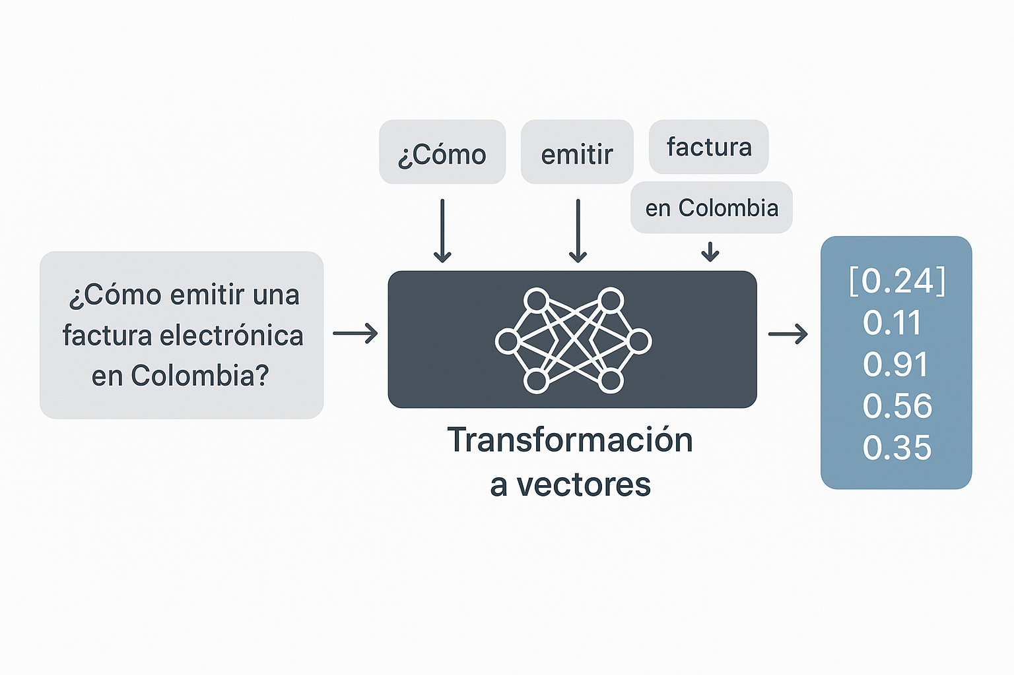

Now, the fascinating thing: the "distance and direction" (the vector) to go from "Man" to "Woman" is almost identical to the distance and direction to go from "King" to "Queen." This means that the model has learned the relationship ofl sexo.
Vector(Reina) ≈ Vector(Rey) - Vector(Hombre) + Vector(Mujer)
This same logic applies to much more complex concepts:
- Synonyms:"Car" and "Automobile" will be practically neighbors on the map.
- Relaciones:"Paris", "France" and "Eiffel Tower" will be grouped in the same "region" of the map. "Tokyo" and "Japan" will be in another region, but the relationship between "Paris" -> "France" will be similar to that of "Tokyo" -> "Japan".
- Meaning of Phrases:Theembeddingof "The weather in Madrid is sunny" will be closer to "Hot weather in the capital of Spain" than to "The weather in Oslo is cold"

We didn't create them. We useModels ofEmbedding pre-entrenados. They are gigantic neural networks that have "read" much of the Internet to learn these semantic relationships.
Its operation is simple for us:
- We take achunkof text.
- We pass it to the modelembedding.
- The model returns us its corresponding vector.
The length of this vector (the number of "dimensions") depends on the model. For example:
- all-MiniLM-L6-v2: 384 dimensiones.
- mxbai-embed-large: 1024 dimensiones.
- OpenAI text-embedding-3-small: 1536 dimensions.
The more dimensions, the greater the ability to capture nuances, although not always "more is better."
One of the great advantages ofMakerAi Delphi Suiteis that it abstracts the complexity of this process. You don't need to know about neural networks to create embeddings.
- The Component:You use a specific component like TAiOllamaEmbeddings or TAiOpenAiEmbeddings.
- The Key Property:In your componentTAiRAGVector, you simply assign the modelembeddingthat you want to use to the Embeddings property.
- The Execution:When you call methods likeAddItemorAddItemsFromPlainText, the componentTAiRAGVectorautomatically communicates with the componentembeddingassigned to convert eachchunkof text into its corresponding vector before storing it.
// In theObjectInspector, you assign OllamaEmbeddings1 to the RAGVector1.Embeddings property

// Then in the code, the process is transparent:
procedure TFormPrincipal.BtnIndexarClick(Sender: TObject);
begin
// When calling this method...
RAGVector1.AddItemsFromPlainText(MemoDocumento.Lines.Text, 512, 80);
// ...internally, RAGVector1 is calling OllamaEmbeddings1.CreateEmbedding
// for eachchunkthat generates You don't have to manage it manually.
end;
This process turns our text library into a database of numerical "meanings," ready to be queried not for keyword matches, but for true semantic intent.

D. Almacenamiento (Vector Stores): The Vector Library
Now we have a large number ofchunksof text, and each one has a vector (embedding) associated. Where do we keep them so we can search for themultra-fast?
The answer is aVector Database (Vector Store / VectorDatabase).
- What is a Vector Store?It is a specialized database, optimized to store and search high-dimensional vectors at incredible speed. While a SQL database is good for finding exact matches in text (WHERE name = 'John'), a vector database is good for finding "nearest neighbors" (find_nearest_neighbors), that is, thechunkswhose meaning is more similar to the user's question.
- Opciones Populares:
  - Local / In memory:Ideal for prototyping and rapid development. Examples:FAISS (de Meta), ChromaDB.
  - In the Cloud / Production:Managed, scalable and robust solutions. Examples:Pinecone, Weaviate, Qdrant, Milvus.
At the end of the indexing phase, we have transformed a set of static documents into a living and searchable knowledge base. We have a library where each book has been broken down into paragraphs (chunks), and each paragraph has a tab in a semantic catalog (embeddings) that tells us exactly what it is about, all stored in a high-speed search infrastructure (Vector Store).
With this solid foundation, we are ready for the second phase: answering user questions.

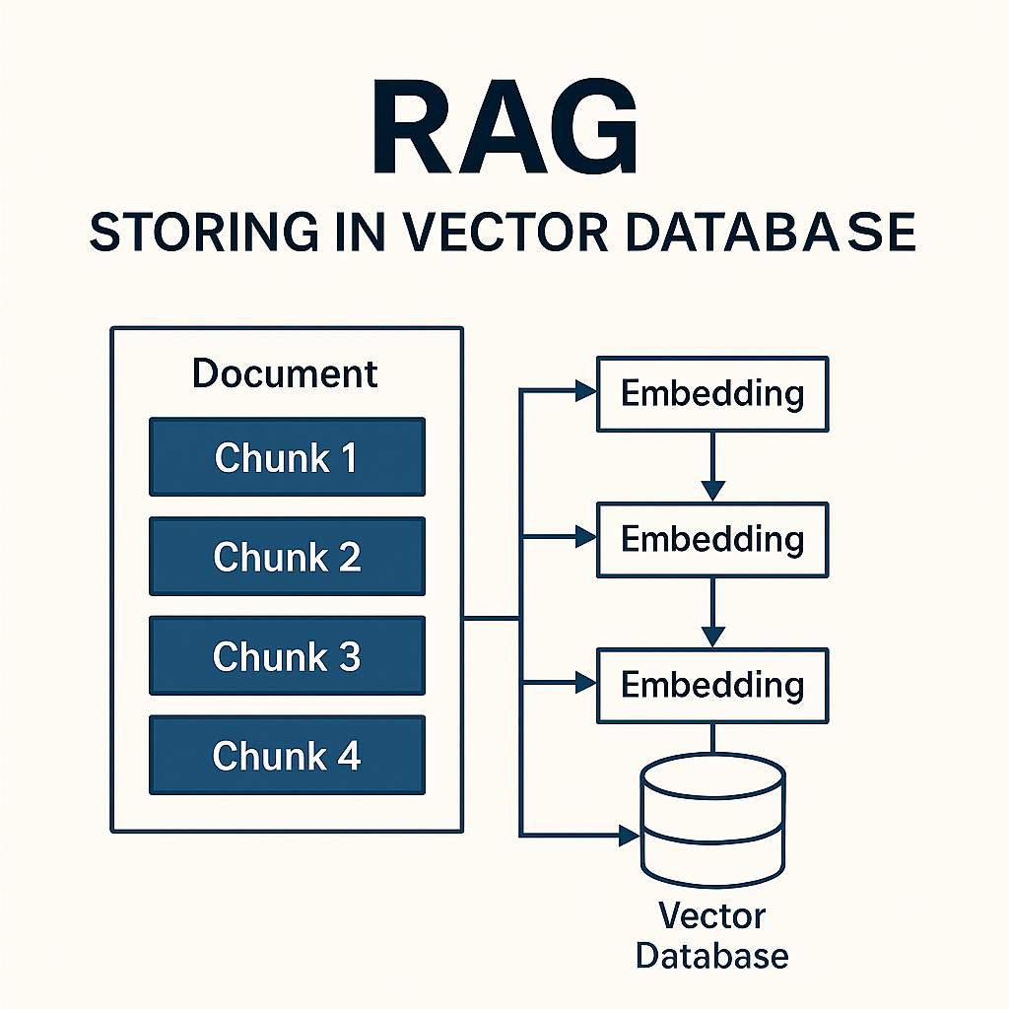

Module 3: Let's get to work! Building your First RAG with MakerAi Delphi Suite
In the previous modules, we have explored the theory: why we need RAG, what its components are, and how it fits into the current AI landscape. Now is the time to stop talking and start building.
In this module, we will guide you step by step to create your first functional RAG system from scratch, using the power and simplicity ofMakerAi Delphi Suite. You will see how easy it is to transform a simple text into a searchable knowledge base.
We will build a basic system and, most importantly, look at its limitations to understand why optimization techniques are so crucial.

Tutorial Objective
We will create a "Questions and Answers" application on a text document. The goal is to be able to ask questions in natural language of this document and obtain answers based on its content.
Tools we will use:
- RAD Studio / Delphi:Our development environment.
- MakerAi Delphi Suite:
  - TAiOllamaEmbeddings: To generate the vectors (embeddings). We will use Ollama because it is local and free, but it could be any other component ofembedding.
  - TAiRAGVector: The heart of our RAG system for managing indexing and searching.
- PostgreSQL with extensionpgvector:Our vector database. We will use the database implementation from the demo, since it is the most robust for a real case.

1. Tutorial: Creating a Basic RAG in Delphi
We are going to recreate the functionality of the demo that we saw, but explaining each step from the perspective of the manual.

Step 1: Environment Configuration
Before writing a line of Delphi code, make sure you have:
- Ollama running:With a downloaded embeddings model, such asmxbai-embed-large.
- PostgreSQL instalado:With the extensionpgvectorenabled in your database.
- A table to store the embeddings.The structure could be similar to the one inferred by the demo:
CREATE TABLE IF NOT EXISTS anexos (
id SERIAL PRIMARY KEY,
resumen TEXT,
categoria VARCHAR(255),
filename VARCHAR(255),
fechadoc TIMESTAMP,
embedding VECTOR(1024) -- The dimension must match your modelembedding
);

Step 2: User Interface Design in Delphi
In a new form, place the following components:
- ATMemo (MemoDocumento) to paste the text we want to index.
- ATButton (BtnIndexar) to start the indexing process.
- ATEdit (EditPregunta) for the user to write their question.
- ATButton (BtnPreguntar) to perform the search.
- ATMemo (MemoRespuesta) to display the retrieved context.
- MakerAi components (from palette):
  - TAiOllamaEmbeddings (OllamaEmbeddings). Configura su propiedad Model a 'mxbai-embed-large:latest'and theDimensions a 1024.
  - TAiRAGVector (RAGVector). This is our orchestrator.
  - TFDConnection (DbConn) to connect to PostgreSQL.
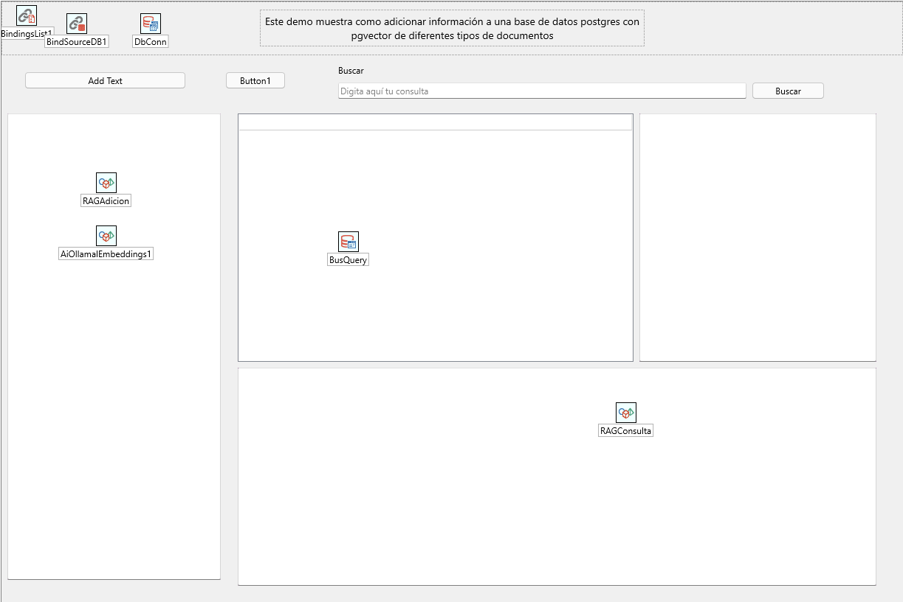
Now, assign the componentOllamaEmbeddingsto the Embeddings property of the componentRAGVectorin theObject Inspector.

Step 3: The Indexing Phase (Load, Split and Store)
The heavy lifting here will be done by the methodAddItemsFromPlainTextand the eventOnDataVecAddItem.
- ChunkingAutomatic:The methodAddItemsFromPlainTextwill be responsible for dividing the text of theMemoDocumentoinchunksof a defined size and overlap. This is the implementation ofChunkingFixed Size with Overlay.
- Generation of Embeddings and Storage:For eachchunk, TAiRAGVectorwill call internallyOllamaEmbeddingsto get the vector and then it will fire our event to save it to the database.
Code for the buttonBtnIndexar:

procedure TFormPrincipal.BtnIndexarClick(Sender: TObject);
var
TextoCompleto: String;
// Puedes aÃ±adirmetadata if you want, but we'll keep it simple for now.
// Md: TAiEmbeddingMetaData;
begin
TextoCompleto := MemoDocumento.Lines.Text;
if TextoCompleto.IsEmpty then
begin
ShowMessage('Please paste some text into the document to index.');
Exit;
end;

// Â¡Magia! ThislÃ­neadoes thechunkingand fire the eventOnDataVecAddItemfor eachchunk.
// Usamos chunks512 characters with an overlap of 80.
RAGVector.AddItemsFromPlainText(TextoCompleto, 512, 80);

ShowMessage('Documento indexado correctamente.');
end;

// The eventOnDataVecAddItemIt takes care of persistence in PostgreSQL.
procedure TFormPrincipal.RAGVectorDataVecAddItem(Sender: TObject;
aItem: TAiEmbeddingNode; MetaData: TAiEmbeddingMetaData; var Handled: Boolean);
var
Query: TFDQuery;
sEmbedding: String;
JArr: TJSonArray;
begin
Query := TFDQuery.Create(nil);
Query.Connection := DbConn;
try
JArr := aItem.ToJsonArray;
try
sEmbedding := JArr.ToString;
finally
JArr.Free;
end;

Query.SQL.Text := 'INSERT INTO anexos(resumen, embedding) VALUES (:resumen, :embedding)';
Query.ParamByName('resumen').AsString := aItem.Text; // We save the text of thechunk
Query.ParamByName('embedding').AsString := sEmbedding; // We save the vector
Query.ExecSQL;

Handled := True; // Â¡Importante! We inform the component that we have handled it.
finally
Query.Free;
end;
end;

Step 4: The Inference Phase (Search and Generate Answer)
Now, we will implement the logic to answer questions.
- Creation ofEmbeddingfor the Question:When we callRAGVector.SearchText, the component will take the user's question, useOllamaEmbeddingsto convert it into a vector...
- Database Search:...and then it will fire the eventOnDataVecSearchfor us to perform the similarity search in PostgreSQL.
- Context Return:The methodSearchTextfinally it will return a concatenation of the text of thechunksmore relevant.
Code for the buttonBtnPreguntar:

procedure TFormPrincipal.BtnPreguntarClick(Sender: TObject);
var
Pregunta, ContextoRecuperado: String;
begin
Pregunta := EditPregunta.Text;
if Pregunta.IsEmpty then
begin
ShowMessage('Please write a question.');
Exit;
end;

// ThisÃºnica lÃ­neaorchestrate thebÃºsqueda.
// BuscarÃthe 5 chunks mÃ¡srelevant without precision threshold.
ContextoRecuperado := RAGVector.SearchText(Pregunta, 5, 0.0);

MemoRespuesta.Lines.Text := '--- Contexto Recuperado ---' + #13#10 +
ContextoRecuperado;
end;

// The eventOnDataVecSearchtakes care of thebÃºsquedain PostgreSQL.
procedure TFormPrincipal.RAGVectorDataVecSearch(Sender: TObject;
Target: TAiEmbeddingNode; aLimit: Integer; aPrecision: Double;
var aDataVec: TAiRAGVector; var Handled: Boolean);
var
Query: TFDQuery;
sEmbedding: String;
JArr: TJSonArray;
EmbNode: TAiEmbeddingNode;
begin
// We create a temporal vector to return the results.
aDataVec := TAiRAGVector.Create(nil);

Query := TFDQuery.Create(nil);
Query.Connection := DbConn;
try
JArr := Target.ToJsonArray;
try
sEmbedding := JArr.ToString;
finally
JArr.Free;
end;

// The magic ofpgvector: The <-> operator calculates the cosine distance.
Query.SQL.Text := 'SELECT resumen, embedding <-> :embedding as distancia ' +
'FROM anexos ORDER BY distancia LIMIT :limit';
Query.ParamByName('embedding').AsString := sEmbedding;
Query.ParamByName('limit').AsInteger := aLimit;
Query.Open;

// We fill the results vector with the retrieved text.
while not Query.Eof do
begin
EmbNode := TAiEmbeddingNode.Create(Target.Dim);
EmbNode.Text := Query.FieldByName('resumen').AsString;
aDataVec.Items.Add(EmbNode); // We do not useAddItemto not generate embeddings again
Query.Next;
end;

Handled := True; // Â¡Importante!
finally
Query.Free;
end;
end;

Step 5: Test the System and Observe its Limitations
Ahora, ¡a probar!
- Index a text:Copy a Wikipedia article about, for example, "Artificial Intelligence." Paste it onMemoDocumentoand clickBtnIndexar.
- Ask a simple question:Write inEditPregunta:What is the Turing test? and clickBtnPreguntar. You should see inMemoRespuestathe paragraphs of the article that talk about Alan Turing and his test. Works!

Now, let's look for the cracks (the limitations):
Try a more complex document, such as a made-up financial report that contains phrases like:
- "In the company's Q1 2023 reportInnovateCorp, revenue was $5M. ForTechSolutions, Q1 2023 revenue was $8M."
- Now, ask the question: What was the income ofInnovateCorp?
- The basic RAG system could recover bothchunksbecause the phrase "Q1 2023 revenue" is semantically very similar in both. The recovered context could be:
- "In the company's Q1 2023 reportInnovateCorp, revenue was $5M. ForTechSolutions, Q1 2023 revenue was $8M."
If we send this to an LLM, they might get confused or, worse, average the numbers or give the wrong answer. The problem is that ourchunk, being a simple piece of text,has lost some of its crucial original context(which company exactly each entry data belongs to).
This limitation is the perfect springboard for our next topic: how we can enrich ourchunksto make them "smarter" and more precise.

Module 4: Optimization Masterclass: Creating a Production RAG Ecosystem
Congratulations on building your first RAG system in Module 3. You now have a working application. However, in the real world, "it works" is not enough. We need it to be precise, robust and efficient.
This module is a deep dive into the art of optimization. We're going to take apart our basic RAG and rebuild it piece by piece using advanced techniques that make the difference between a prototype and a production-ready system. The quality of a RAG depends almost entirely on the quality of the information it recovers. If the context is poor, the LLM response will be poor too.
For more complex strategies, we will use the power of the orchestratorTAIAgentsof MakerAi Delphi Suite, which will allow us to design intelligent and dynamic workflows.

1. Chapter 1: The Definitive Catalog of Marketing StrategiesChunking
As we have already discussed, thechunking(the way you divide your documents) is the most critical decision in the entire pipeline. Poor division can hide information or destroy context. Here we explore the main strategies and how to implement them.

Category 1: Basic Strategies (Based on Fixed Structure)
- 1. Fixed Size with Overlay:
  - What is it:Splits text into chunks of N characters, with M characters overlapping.
  - When usarlo:An excellent and robust starting point, especially for unstructured text.
  - Implementation with MakerAi Delphi:It is the native function of the RAG component.
RAGVector.AddItemsFromPlainText(TextoCompleto, 512, 80);
- 2. By Prayer:
  - What is it:Break up the text at the end of each sentence, ensuring that eachchunkbe a complete grammatical unit.
  - When usarlo:Ideal for well-written texts such as articles or books.
  - Implementation with MakerAi Delphi:Requires apre-procesamiento simple.
uses System.RegularExpressions;
// ...
Oraciones := TRegEx.Split(TextoCompleto, '(?<=[.!?])\s+');
for Oracion in Oraciones do
RAGVector.AddItem(Oracion.Trim, nil);

Category 2: Content and Structure Aware Strategies
- 3. Structured (e.g. by Headings)Markdown):
  - What is it:Use the logical structure of the document (headers, sections) to define the limits of thechunks.
  - When usarlo:The best option when your documents are structured (documentation, web pages).
  - Implementation with MakerAi Delphi: Requiere parsearthe structure before indexing.
// Pseudocode to index by headersMarkdown
ChunkActual := TStringBuilder.Create;
for Linea in MarkdownTexto.Lines do
begin
if Linea.StartsWith('#') and (ChunkActual.Length > 0) then
begin
RAGVector.AddItem(ChunkActual.ToString, nil);
ChunkActual.Clear;
end;
ChunkActual.AppendLine(Linea);
end;
// Add the lastchunk...

Category 3: Advanced and Semantic Strategies

This is where we start using AI to improve ourchunking.
- 4. ChunkingSemantic:
  - What is it:Measures the similarity in meaning between consecutive sentences and cuts when the topic changes dramatically.
  - When usarlo:To obtain maximum thematic coherence in eachchunk.
  - Implementation with MakerAi Delphi:It is an algorithm that you can build yourself using the base components.
    - Divide the text into sentences.
    - For each sentence, generate itsembedding: Embedding := OllamaEmbeddings.CreateEmbedding(Oracion, 'user');.
    - Calculate the cosine similarity between adjacent sentences:TAiEmbeddingNode.CosineSimilarity(Emb1, Emb2);.
    - When the similarity falls below a threshold, thechunkcurrent one and start a new one.
- 5. Chunking Agentic:
  - What is it:We delegate the task of breaking down the text to an LLM, asking him or her to identify the most logical chunks.
  - When usarlo:When quality is the top priority and cost/speed are not an issue.
  - Implementation withTAIAgents:This is a perfect use case for a workflowagentic.
    - Nodo 1:Read the document.
    - Nodo 2 (LLM Chunker):Ask an LLM to split the text into a JSON format.
    - Nodo 3: Parseathe JSON and useRAGVector.AddItemto index eachchunk.

2. Chapter 2: Beyond Simple Search: Transformations and Routing
Once your data is well indexed, the next point to optimize is the user's own question. This is where the orchestratorTAIAgentsit becomes our main tool to build reasoning flows.

Technique 1: Query Transformation (Query Transformation)
- A. Multi-Query:
  - What is it:Generate multiple questions from different perspectives from the user's original question to expand the search.
  - When usarlo:For complex or comparative questions.
  - Implementation withTAIAgents:
    - Nodo 1 (LLM):Generates 3 variants of the question and saves them to the Blackboard.
    - Node 2 (Fork):It is divided into three parallel branches.
    - Nodes 3a, 3b, 3c (RAG Search):Each branch runsRAGVector.SearchTextwith one of the variants.
    - Node 4 (Union):Wait for all searches to finish (JoinMode = jmAll).
    - Node 5 (LLM Synthesis):Combine all the results and generate the final answer.
- B. Step-Back Prompting:
  - What is it:For a very specific question (e.g. "What function of the TForm class allows you to change the background color?"), a more general or "step back" question is first generated (e.g. "How do you customize the appearance of a TForm in Delphi?"). Context is sought for the general question, providing high-level information that helps answer the specific question.
  - When usarlo:When the questions are very detailed and can benefit from a broader context.
  - Implementation withTAIAgents:
    - Nodo 1 (LLM):Generates the “step-back” question and saves it to the Blackboard.
    - Node 2 (RAG Step-Back Search):Find context for the general question.
    - Node 3 (Specific RAG Search):Find context for the original question.
    - Node 4 (LLM Synthesis):Use both contexts to formulate the final answer.

Technique 2: Intelligent Routing (Routing)
- What is it:Direct the user's question to the correct knowledge base (e.g. 'technical documentation' vs. 'marketing').
- When usarlo:When you have multiple disparate data sources.
- Implementation withTAIAgents:
  - Nodo 1 (LLM Enrutador):Classify the question and save the decision (e.g. 'tecnica') on the Blackboard with the keynext_route.
  - Link Condicional:Use the keynext_routeto direct the flow to the appropriate search node.
  - Search Nodes:Each node is connected to aTAiRAGVector diferente.

3. Chapter 3: Improving Relevance:Re-rankingand AutoCorrect
We have recovered a set of documents. Are we sure they are the best? What if they are irrelevant? These final techniques act as a quality check before generation.

Technique 1:Re-classification (Re-ranking)
- What is it:Vector search isfast,but sometimes it is not the most precise in terms of relevance. There-rankinguses a second, more powerful but slower model (usually a Cross-Encoder), to reorder the X best results obtained from the initial search. This model evaluates the relevance of eachchunkregarding the question in a much more precise way.
- When usarlo:In applications where response accuracy is critical. It's a small sacrifice in latency for a big gain in quality.
- Implementation withTAIAgents:
  - Node 1 (Initial RAG Search): Usa RAGVector.Searchto obtain, for example, the 25 bestchunks. Save the list ofchunkson Blackboard.
  - Nodo 2 (Re-ranker):This node iterates over 25chunks. For each one, it makes a call to a modelre-ranking(like those ofCohereor open modelssource) which returns a relevance score. Reorder the listchunksaccording to this new score.
  - Node 3 (Selection):Take the top 5chunksof the reordered list.
  - Node 4 (LLM Synthesis):Generate the response using only the highest quality context.

Technique 2: FlowsAgenticAutoCorrect (Self-Correction)
This is the pinnacle of RAG optimization. The system becomes "aware" of the quality of its own information and can decide to act accordingly.
- What is it:After retrieving the context, an LLM evaluates it. Is it relevant to the question? Does it contain the answer? If the answer is no, the system may decide to perform a new search, perhaps transforming the question, rather than generating a garbage answer.
- When usarlo:In mission-critical systems that cannot afford incorrect or "I don't know" answers.
- Implementation withTAIAgents(an example of a correction cycle):
  - StartNode:Receive the original question.
  - Nodo_Busqueda_RAG:Perform the initial search withRAGVector.
  - Nodo_Evaluador (LLM):Receives the retrieved context and the question. It asks an LLM: "Is the following context sufficient to answer the question? Answer only 'YES' or 'NO'." Guarda the respuesta in Blackboard like next_route.
  - Link_Condicional:
    - Yesnext_routeis 'YES', the flow willNodo_Sintesis_Final.
    - Yesnext_routeis 'NO', the flow returns to aNodo_Refinador_De_Query (LLM).
  - Nodo_Refinador_De_Query (LLM):It takes the original question and the "bad" context and asks an LLM: "The previous search failed. Generate a new question to find the missing information."
  - Link_Bucle:The output of this node is connected back toNodo_Busqueda_RAGto retry the search with the new question. The link must have aMaxCiclesto avoid infinite loops.
This module has taken you from a simple RAG to an ecosystemagenticcomplex and robust. You don't need to implement all of these techniques for every project, but now you have aarsenal of tools at your disposal. The key is to identify the weak point of your pipeline and apply the correct optimization, and as you have seen, the combination of TAiRAGVector and TAIAgents te gives the power and flexibility to build almost any architecture you can imagine.

Module 5: The Frontiers of RAG: Structured Data and Multimodality
So far, we have mastered building and optimizing RAG systems that work with unstructured text. We have converted manuals, articles and documents into searchable knowledge bases. But the real world is much more complex. Information doesn't always come in well-formed paragraphs; It is often presented in tables, relational databases, images and diagrams.
In this module, we will explore the frontiers of RAG. We will investigate two of the biggest challenges and areas of active research in the AI ​​community: how to make RAG understand structured logic and how to make it "see" beyond the text.

1. RAG is not Enough: The Transition to Structured RAG
The RAG we've built so far, based on vector similarity search, is incredibly powerful. However, it has a fundamental weakness that the article "RAGis Not Enough" describe brillantemente.

The Problem: RAG Operates with "Vibes", not Logic
Our current RAG works by finding texts that "feel" similar to the question. It is a system ofsemantic similarity. If you ask "Who approved the marketing budget?", it will look for snippets that contain words like "budget," "approved," and "marketing."
This works great for open or exploratory questions. But it fails miserably when you needlogical and absolute precision.
Imagine that you need to respond to:
"Show me all budget approvals made by 'John Smith' for the 'Marketing' department in 'Q2 2023' that exceed '$10,000'."
A standard vector RAG is almost useless here. You cannot apply logical filters (DEPARTMENT = 'Marketing' AND YEAR = 2023 AND AMOUNT > 10000). It will simply return a bunch of paragraphs that talk about budgets and John Doe, leaving you the job of filtering and verifying.

The Solution: Structured RAG and Knowledge Graphs
TheRAG EstructuradoIt is an evolution that does not seek similarity, buthechos verificables. The process changes fundamentally in the indexing phase:
- Entity Extraction:Instead of simply splitting the text intochunks, an LLM is used to analyze each document and extract information structured in the form of "triples":(Sujeto, Predicado, Objeto).
  - The phrase: "Juan Pérez approved the $15,000 marketing budget on April 5, 2023"
  - It becomes facts:
    - (John Perez,es_un, Empleado)
    - (Marketing Budget,tiene_monto, $15,000)
    - (Marketing Budget,tiene_fecha, 2023-04-05)
    - (Juan Pérez, approved, Marketing Budget)
- Construction of a Knowledge Graph:These facts are not stored in a vector database, but in agraph database(like Neo4j). In a graph, entities are nodes and relationships are edges, creating an interconnected map of all your knowledge.
- Logical Query:When a user asks a question, an LLM translates it into a graph query language (such asCypherfor Neo4j). The query does not search for "similarity", but traverses the graph to find a path that satisfies all the logical conditions of the question.

How does MakerAi Delphi Suite fit into this?
MakerAi Delphi Suite andsu sistema agentic TAIAgentsIt is the perfect tool to build the pipeline ofknowledge extraction.
You can design a workflow to build your graph:
- Node 1 (Document Reader):Read a document.
- Node 2 (LLM Entity Extractor):Use an LLM with a very specific prompt to extract the Subject-Predicate-Object triples in JSON format.
- Node 3 (Graph Writer): Parseathe JSON and execute the INSERT statements in your graph database (e.g. Neo4j) through its API or driver.

Structured RAG does not replace vector RAG; complements it. A hybrid system can use a router (built withTAIAgents) to decide if the user's question is exploratory (and send it to theTAiRAGVector) or logic (and send it to the graph engine).

 | Vector RAG (Standard) | RAG Estructurado (Grafo)
Principio | Semantic similarity ("vibes") | Logical facts ("truth")
Ideal for | Preguntas abiertas, exploratorias. | Precise questions with filters.
Ventajas | Flexible, easy to implement. | High precision, zero hallucinations, auditable.
Desventajas | Less precise, you can hallucinate. | Expensive to build, rigid.

2. The Multimodal Challenge: Can RAG “See” and Understand?
The last frontier ismultimodalidad. Can we ask a RAG system questions about images, flowcharts, or data in a table within a PDF? The promise isVision-Language Models (VLMs), such as GPT-4o or Gemini, which can process both text and images.
The idea of a "RAG 3.0" is simple: we extract images and tables from our documents, index them (perhaps with multimodal embeddings), and provide them to a VLM as context. Sounds good, right? However, recent research, such as that summarized in the paper “RAG in Multimodal Environments,” reveals a fundamental problem.

The Problem: TheVLMsThey are "Sophisticated Imitators", not Real Learners
The hope was that theVLMscould do "learning in context" (In-Context Learning), that is, learning to perform a new task simply by seeing a few examples at the prompt.
- The Key Experiment:The researchers gave theVLMsa task (e.g. counting objects in a picture) and were shown examples.
  - Prueba 1 (In-Distribution):The examples and the final question used the same type of images. Here, the models worked well.
  - Prueba 2 (Out-of-Distribution):The examples used one type of image (e.g., cartoons) and the final question used another (e.g., real photos). This is where the modelsthey failed catastrophically. Their performance worsened as they were given more "incorrect" examples.
- The Conclusion:TheVLMsthey were not learning themethodto solve the task. They were simplyimitating the format and style of the response from the examples. When the final question did not fit the style of the examples, they became confused. They cannot generalize their learning to new domains from a few examples.

What Does This Mean for the Future of RAG?
- Multimodal RAG is Extremely Difficult:Building a RAG system that can reliably answer complex questions about mixed images, tables, and text remains a research goal. Current systems are fragile and cannot be relied upon for critical production tasks.
- The "Zero-Shot"is the King (for now):TheVLMsThey are excellent at following direct instructions on an image given to them (zero-shot). For example: "In this picture, how many red apples are on the table?" They work well. But they fail if you try to "teach" them a complex method with examples.
- MakerAi Delphi Tools Still Relevant:Although background AI is still maturing, the architecture you've learned is still valid.
  - Puedes usar TAIAgentsto create a flow that extracts images and text from a document.
  - You can use aVLMlike aherramienta (TAiToolBase)within a node. The flow could be:
    - Node 1 (Text RAG):The user asks: "What does the architecture diagram show?" The text RAG finds the paragraph that mentions "the diagram in Figure 3."
    - Node 2 (Image Extractor):The system extracts "Figure 3" from the document.
    - Nodo 3 (Herramienta VLM):Send the image and the original question to a VLM (using its API) in modezero-shot.
    - Nodo 4 (Respuesta):Presents the VLM response to the user.

In summary, the dream of a universal RAG that reasons fluidly on any type of data is still on the horizon. However, by understanding current limitations, we can build smarter, more realistic systems today, using agentic architectures to orchestrate specialized tools for each type of data, a capability thatMakerAi Delphi Suiteputs you at your fingertips.

Module 6: From Prototype to Reality: Evaluation and Deployment
You have reached the final stage of our journey. You have learned how to build, optimize and expand the limits of RAG systems. You have an application that, in your tests, seems to work great. But how do you prove it? How can you be sure that a change in strategychunkingOr did the system really improve at the prompt? And what does it take to make this application work reliably for thousands of users?
This last module is the bridge between your prototype in the development environment and a robust application in the real world. We will address two fundamental pillars:rigorous evaluationand theconsiderations for putting into production.

1. Rigorous Evaluation: How Do We Know if Our RAG Works?
"Works on my machine" is not a metric. To systematically improve your RAG system, you need objective metrics. RAG evaluation is an active and complex field, but it can be broken down into the measurement of its two main components: the quality of theRecoveryand the quality of theGeneration.
The general evaluation process involves:
- Create a Test Data Set:You need a list of example questions (question) and, ideally, the known correct answers (ground_truth_answer).
- Ejecutar tu Pipeline:You run each question through your RAG system to get the contexto recuperado (retrieved_context) and the respuesta generada (generated_answer).
- Calculate Metrics:You compare the results to the ground truth to obtain objective scores.

Key Metrics (Based on the frameworkRAGAs)
These metrics are the industry standard for evaluating the quality of a RAG pipeline. The interesting thing is that many of them can be calculated using LLMs as judges.
- Faithfulness(Fidelity): Is the answer based on context?
  - Question answered:Is the LLM "hallucinating" or making up information that was not in the recovered fragments?
  - How to measure:An LLM is asked to act as a judge. You are given thegenerated_answerand theretrieved_context, and you are asked: "Analyze each sentence in the answer. Can you verify that all the information in the answer comes directly from the context provided? Counthow many statements are verifiable and how many are not." The result is a score from 0 to 1.
  - Importancia:Maximum! A low fidelity score indicates that your system has a serious hallucination problem.
- Answer Relevancy(Relevance of Answer): Is the answer useful to the question?
  - Question answered:Does the generated response really answer the user's question, or does it ramble or focus on irrelevant details?
  - How to measure:An LLM-as-judge receives thequestionand thegenerated_answer. You are asked to rate how well and directly the answer addresses the question.
  - Importancia:High. You can have an answer faithful to the context, but if the context itself was poor, the answer may be useless.
- Context Precision(Context Accuracy): Is the information retrieved useful?
  - Question answered:Of all the fragments you recovered, how many were actually relevant to the question?
  - How to measure:An LLM-as-judge examines thequestionand theretrieved_context. You are asked to identify which sentences in the context are directly relevant to answering the question. The score is the proportion of relevant sentences out of the total.
  - Importancia:Very high. Low precision means that you are "polluting" the LLM prompt with useless information, which can confuse it.
- Context Recall(Comprehensiveness of Context): Do we recover all the necessary information?
  - Question answered:Does the retrieved context contain all the information necessary to fully respond to theground_truth_answer?
  - How to measure:An LLM-as-judge compares theground_truth_answerwith himretrieved_contextand determines if the context is sufficient to have generated that ideal response.
  - Importancia:Crucial to ensure that your answers are not only correct, but also complete. Low completeness could be a sign of a bad strategy.chunking.
Evaluation Implementation with MakerAi Delphi Suite
Although there is no one-click "evaluation component", you can use the orchestratorTAIAgentsto build your own evaluation harness.
- Create aTAiToolBasefor each metric.For example, aTFaithfulnessTool.
- The methodExecuteFrom this tool you would take the response and context, construct the appropriate assessment prompt, and call an LLM to obtain the score.
- Design a flow inTAIAgents que:
  - Read a question from the data set.
  - I passed itthrough your RAG pipeline to get the response and context.
  - Run the nodes that call your different evaluation tools in parallel.
  - Aggregate the results and save them in a report.
This approach allows you to experiment with different configurations (models,chunking, prompts) and get a quantitative report to see which one works best.
Frameworks Externos: RAGAsandDeepeval
For large-scale projects, consider integratingframeworksspecialized Python scripts likeRAGAs. You can do this from Delphi using Python4Delphi, giving you access to these powerful evaluation tools without having to reinvent the wheel.

2. Putting into Production (Deployment)
You have evaluated and optimized your system. Now it's time to take it to the real world. This introduces a new set of challenges that go beyond the code.
A. Architectural Considerations
- Separation of Services:Don't run indexing and inference in the same application.
  - Indexing Pipeline (Offline):It should be a separate process (for example, a console application or a Windows service) that runs periodically or when documents change. Its only task is to process documents and populate your vector database.
  - Inference API (Online):Your main application (for example, a Delphi web server withWebBrokeror MARS) should only handle user questions. This API will receive a question, convert it into aembedding, it will query the vector database and call the LLM.
- Scalable Vector Database:WhileChromaDBor FAISS are great for development, in production you need a robust and scalable solution likePostgreSQL withpgvector(like in our demo),Pinecone, WeaviateorMilvus.

B. Latencia
Users expect quick responses. The total latency of your RAG system is the sum of:
- Time ofembeddingof the question (usually quickly).
- Search time in the vector database (must be < 100ms).
- LLM inference time (the biggest bottleneck).
- Network latency between all services.
To reduce latency:
- Use smaller, faster LLM models if possible.
- Implementa streamingof responses: Instead of waiting for the full response from the LLM, show it to the user word by word as it is generated. APIs from major vendors and Ollama support this.
C. Costos
- LLM API Costs:This will probably be your biggest expense. Each question to your RAG system triggers one (or more, in flowsagentic) call to the LLM API. Monitor your token usage closely.
- Costs ofEmbedding:Some services (such as OpenAI) charge for generating embeddings. Using local models with Ollama can reduce this to zero, at the expense of hardware cost.
- Infrastructure Costs:The hosting of your API, the vector database and the indexing pipeline.
D. Monitoring andLogging
You can't fix what you can't see. Your system in production must have alogging exhaustivo:
- Record each question and the response generated.
- Records the recovered context.This is vital for debugging why an answer was incorrect.
- Monitor evaluation scores.Implement random sampling of production interactions and run them through your evaluation harness to detect if system quality degrades over time.
- Records latency and error rateof each component.

With this module, you have completed the life cycle of an AI project: from the initial idea, through construction and rigorous optimization, to practical considerations for real-world deployment. You are now equipped not only to build RAG systems, but to buildhigh quality RAG systemswith Delphi and the powerfulMakerAi Delphi Suite.

Appendix A: Glossary of Key Terms
A quick reference for all the concepts and acronyms we have used throughout this manual.
- Agente (Agent):An autonomous system that uses an LLM to reason, plan, and execute a sequence of actions to achieve a goal. In MakerAi Delphi, the componentTAIAgents permite construir estos sistemas.
- Hallucination (Hallucination):It occurs when an LLM generates factually incorrect, invented or meaningless information, but presents it as if it were a true fact.
- Vector Database (Vector Store / VectorDatabase):A specialized database designed to efficiently store and search high-dimensional vectors. Examples: PostgreSQL withpgvector, Pinecone, ChromaDB.
- Chunking:The process of breaking down a large document into smaller, more manageable chunks of text ("chunks") before generating your embeddings.
- Contexto (Context):The information (generallychunksof recovered text) that is provided to an LLM along with the user's question to base their answer on.
- Distancia Coseno (Cosine Distance / Similarity):A mathematical metric used to measure the similarity between two vectors in a multidimensional space. A cosine similarity of 1 means that the vectors are identical in direction; 0 means they are orthogonal (not related).pgvectoruses the <-> operator for distance calculation.
- Embedding:A numerical representation (a vector) of a piece of text, image, or other data. Embeddings capture semantic meaning, so that elements with similar meanings have nearby vectors in space.
- Knowledge Graph (Knowledge Graph):A way to store data structured as a network of entities (nodes) and the relationships between them (edges). Used in Structured RAG.
- In-Context Learning:The (often limited) ability of an LLM to "learn" to perform a task from a few examples provided directly at the prompt, without the need forre-entrenamiento.
- Indexing (Indexing):The offline process of preparing knowledge: uploading documents, dividing them intochunks, generate their embeddings and store them in a vector database.
- Inferencia (Inference):The online, real-time process of receiving a question, retrieving context, and generating a response.
- LLM (Large Language Model- Large Language Model):A large-scale artificial intelligence model trained on vast amounts of text, capable of understanding and generating human language. Examples: GPT-4, Llama 3, Claude 3.
- Multimodalidad (Multimodality):The ability of an AI model to process and understand information from multiple types of data, such as text, images, audio, and video.
- Prompt:The instruction or question given to an LLM to generate a response.
- Prompt Aumentado (Augmented Prompt):In RAG, it is the final prompt sent to the LLM, containing both the user's original question and the recovered context.
- RAG (Retrieval-Augmented Generation):The architecture that improves the responses of an LLM by first retrieving relevant information from an external knowledge base and providing it as context.
- Recovery (Retrieval):The phase of a RAG system responsible for searching and finding thechunksof information most relevant to a given question.
- VLM (Vision-Language Model- Vision-Language Model):A type of LLM that can process and understand both text and images.

Appendix B: Tools and Components Ecosystem
A summary table of the tools discussed and how they fit into the RAG ecosystem withMakerAi Delphi Suite.
Tarea / Concepto | Herramienta/Componente MakerAi Delphi | Alternativas / Complementos (Externos)
Agent Orchestration | TAIAgents | LangGraph (Python), LangChain Agents (Python)
RAG Management | TAiRAGVector | LangChain, LlamaIndex (Python)
Models ofEmbedding | TAiOllamaEmbeddings, TAiOpenAiEmbeddings, etc. | Models ofHugging Face, Cohere, OpenAI
Language Models (LLM) | TAiOllamaChat, TAiOpenAiChat, etc. | GPT-4, Llama 3, Claude 3, Mistral
Vector Database | Implementation in events (OnDataVecSearch) | PostgreSQL/pgvector, Pinecone, Weaviate, Milvus
Graph Database | (Accessed via API/driver in aTAiToolBase) | Neo4j, TigerGraph
RAG Assessment | Can be built withTAIAgents + TAiToolBase | RAGAs (Python), Deepeval (Python), ARES (Python)

Appendix C: Additional Resources and Recommended Reading
For those who want to dig even deeper, here is a curated list of articles, blogs, and resources that have inspired much of the advanced content in this manual.
- Blogs and Fundamental Articles:
  - "Building the Entire RAG Ecosystem and Optimizing Every Component"byFareed Khan:A comprehensive guide to RAG optimization techniques. (Inspiration for Module 4).
  - "RAG is Not Enough: Why Your Next AI Project Demands StructuredData RAG" by MatthewTovbin:The key article that defines the difference between vector and structured RAG. (Inspiration for Module 5).
  - DocumentationLangChainandLlamaIndex:Although we work in Delphi, their blogs and documentation are an inexhaustible source of ideas and explanations about new RAG techniques.
  - Anthropic Blog:They often publish research on the capabilities and limitations of LLMs, such as the "Contextual Retrieval" technique.
- Tools andFrameworksEvaluation:
  - RAGAs (RAG Assessment):The de facto framework for evaluating RAG pipelines. Their documentation explains each metric in detail.https://docs.ragas.io/
  - Deepeval:Another excellent assessment framework for LLMs, with a strong focus on LLM-based metrics.
- Community and Continuous Learning:
  - YouTube channel ofCimaMaker:(Of course!) The place to find how-to tutorials and demos ofMakerAi Delphi Suiteand other technologies.https://www.youtube.com/@cimamaker3945
  - Gustavo Enriquez's GitHub:To access the source code, examples and future updates to the suite.https://github.com/gustavoeenriquez/
  - Subredditslike r/LocalLLaMA:Online communities where the latest advances in open language models are discussed.sourceand RAG techniques.

Appendix C: Vector Similarity Search with pgvector
This appendix provides a complete guide to installing, configuring and usingpgvector, an open source extension for PostgreSQL that enables vector similarity search. This allows nearest neighbor searches (Nearest Neighbor Search) efficiently, directly into the database.

C.1 What ispgvector?
pgvectorextends PostgreSQL to store and query "embeddings" or high-dimensional vectors. These vectors are numerical representations of complex data such as text, images or audio.
Main features:
- Exact and Approximate Nearest Neighbor Search (ANN).
- Support for multiple types of vectors: single precision (vector), half precision (halfvec), binary (bit) and sparse (sparsevec).
- Multiple distance metrics: L2 (Euclidean), inner product, cosine distance, L1 (Manhattan), distanceHammingand Jaccard distance.
- Full integration with the PostgreSQL ecosystem, including ACID transactions,JOINsand disaster recovery.

C.2 Installation ofpgvector
Installation can be done by compiling from source code or using package managers.
This method requires having the C development tools and PostgreSQL header files installed.
- Clone the repositorypgvector. It is recommended to use a stable version tag.
cd /tmp
git clone --branch v0.8.0 https://github.com/pgvector/pgvector.git
cd pgvector
Compile and install the extension.
codeBash
make
sudo make install

Note: If you have multiple versions of PostgreSQL, make sure the commandpg_configin your PATH point to the correct version.
- Make sure you have Visual Studio installed with C++ support.
- Open the terminal "x64 Native ToolsCommand Prompt forVS" as administrator.
- Define the path of your PostgreSQL installation.

set "PGROOT=C:\Program Files\PostgreSQL\16" # Change 16 to your version
- Clona, compila e instala.
cd %TEMP%
git clone --branch v0.8.0 https://github.com/pgvector/pgvector.git
cd pgvector
nmake /F Makefile.win
nmake /F Makefile.win install

pgvectorIt is also available through various package managers and platforms, which simplifies installation:
- Docker: docker pull pgvector/pgvector:pg16
- Homebrew (macOS): brew install pgvector
- APT (Debian/Ubuntu): sudo apt install postgresql-16-pgvector
- Yum/DNF (CentOS/Fedora): sudo dnf install pgvector_16

C.3 Basic Use ofpgvector
Once installed, follow these steps to start usingpgvector.
Connect to your database and run this command. It must be done once for each database where you want to use the extension.

CREATE EXTENSION vector;
You can create a new table or add a column to an existing one. The column must be of type vector(n), where n is the number of dimensions of your vectors.
-- Create a new table
CREATE TABLE items (
id bigserial PRIMARY KEY,
embedding vector(3) -- Example with 3-dimensional vectors
);

-- Or add a column to an existing table
ALTER TABLE items ADD COLUMN embedding vector(3);
Vectors are inserted as text strings in array format.
codeSQL
INSERT INTO items (embedding) VALUES
('[1,2,3]'),
('[4,5,6]');

The main operation is to find the closest vectors to a query vector. To do this, distance operators are used in the ORDER BY clause.

-- Find the 5 nearest neighbors to the vector [3,1,2] using L2 distance
SELECT * FROM items
ORDER BY embedding <-> '[3,1,2]'
LIMIT 5;

Common Distance Operators:
- <->: Distancia L2 (Euclidiana). The direct geometric distance between two points.
- <=>: Cosine Distance. Measures the angle between two vectors. Ideal for text embeddings where the direction of the vector is more important than its magnitude.
- <#>: Producto Interno (negativo). Useful when vectors are normalized. PostgreSQL only supports ascending order (ASC) on indexes, sopgvectorreturns the negated inner product so that "lesser" means "more similar."

C.4 Indexing for Quick Searches (ANN)
By default,pgvectorperforms an exact search, comparing the query vector with all the vectors in the table. This guarantees 100% accuracy, but is slow on large volumes of data.
To speed up queries, you can createApproximate Nearest Neighbor (ANN) Search Indices. These indexes sacrifice a small amount of precision in exchange for dramatically increased query speed.
pgvectorsupports two types of ANN indexes:HNSWandIVFFlat.
- How does it work?Create a multilevel graph where the nodes are the vectors. The search is performed by navigating the graph efficiently to find the nearest neighbors.
- Ventajas:
  - Alto rendimiento:Generally offers the best balance between speed and accuracy (recall).
  - Dynamic:It requires no "training" and can be built on top of an empty table, efficiently adding data on the fly.
- Desventajas:
  - Higher memory consumption:The graph can take up a significant amount of RAM.
  - Slower construction times:Creating the index is more computationally expensive than withIVFFlat.
Creating an HNSW index:You must create an index for each distance metric you plan to use.

--For distance L2
CREATE INDEX ON items USING hnsw (embedding vector_l2_ops);

-- For Cosine distance
CREATE INDEX ON items USING hnsw (embedding vector_cosine_ops);

-- For internal product
CREATE INDEX ON items USING hnsw (embedding vector_ip_ops);
- How does it work?First, group the vectors into n clusters (called "lists") using an algorithm like k-means. During a query, it only searches a subset of the lists closest to the query vector, rather than the entire table.
- Ventajas:
  - Lower memory consumption:Lighter than HNSW.
  - Faster construction times:Especially on very large data sets.
- Desventajas:
  - Lower performance (speed/accuracy):Generally, to get the same precision as HNSW, the query is slower.
  - Requiere entrenamiento:The index must be created on a table that already contains a representative sample of the data so that theclustering inicial sea efectivo.
Creating an indexIVFFlat:The parameterlistsIt is crucial and must be adjusted according to the size of the board.

-- Se recomienda empezar con:
-- lists= N / 1000 (for N <= 1M rows)
-- lists = sqrt(N) (for N > 1M rows)

CREATE INDEX ON items USING ivfflat (embedding vector_l2_ops) WITH (lists = 100);

The choice of index type depends on the specific requirements of your application.
Criterio | HNSW (Hierarchical Navigable Small World) | IVFFlat (Inverted File with Flat Compression)
Performance (Speed/Accuracy) | Superior. It offers the best speed-accuracy ratio for most use cases. | Bueno. Adequate, but may require tuning more parameters (probes) to achieve high precision, which slows down the query.
Index Construction Time | Slower. The construction of the graph is intensive. | faster. Theclusteringand assignment are faster processes.
Memory Usage | Alto. The graph resides in memory for optimal performance. | Bajo. The inverted list structure is more compact.
Data Requirements | Ninguno. It can be built on an empty table and updates well with inserts/updates. | Requiere datos existentes. You need a data sample for "training" (clustering). It is not ideal for very dynamic or empty tables.
Ideal Use Case | Applications that requirelow latency and high precisionin real time, whereData may change frequently. It is the default recommended option. | Applications withvery large and static data sets, where the time ofIndex construction and memory consumption are critical.
General Recommendation:Start withHNSW. It is the most modern and balanced index. Just considerIVFFlatif you encounter severe memory limitations or if HNSW build times are prohibitively long for your specific use case.

C.5 Preparing the Build Environment in Windows 10 and 11
Unlike Linux and macOS, Windows does not include a C++ compiler or the necessary build tools by default. To compilepgvectorfrom source, you must first install the Microsoft development environment.
The easiest way to do this is by installing theVisual Studio Build Tools (Build Tools), which are a lightweight package without the full code editor (IDE).
Installation steps:
- Download the Installer:
  - Visit the official Visual Studio download page:https://visualstudio.microsoft.com/es/downloads/
  - Look for the "Tools for Visual Studio" section (or "Toolsfor Visual Studio").
  - Download the"Build Tools for Visual Studio".
- Run the Installer:
  - Open the downloaded file. The installer will allow you to select the components ("workloads") that you want to install.
- Select the Correct Workload:
  - In the "Workloads" tab, select the option"Development for the desktop with C++" (Desktop development with C++).
  - This selection will automatically install everything you need: the C++ compiler (MSVC), thenmake, the Windows SDK, and standard libraries.
- Instalar:
  - Click the "Install" button and wait for the process to finish.
- Verify Installation:
  - After the installation is complete, you must use a special terminal that automatically configures the paths to the compiler.
  - Open the Windows Start Menu and search"x64 Native Tools Command Prompt for VS".
  - Importante:Right click on it and select"Run as administrator".
  - In the terminal that opens, run the following command to verify thatnmakeis available:
nmake /?
  - If you see the command help, your build environment is ready.
Now you can follow the steps in the sectionC.2.2to compile and installpgvectorin this same terminal.

